**Experiment No. :-1**

**Program :-**

Import java.awt.*;

class Exp1_1 extends Frame{

Exp1_1() {

Label name=new Label("Name ");

name.setBounds(100,100,60,30);

TextField name1=new TextField();

name1.setBounds(200,100,150,30);

Label adress =new Label("Adress ");

adress.setBounds(100,150,60,30);

TextArea adress1=new TextArea(10,20);

adress1.setBounds(200,150,150,70);

Label gender=new Label("Gender ");

gender.setBounds(100,250,60,30);

CheckboxGroup group=new CheckboxGroup();

Checkbox male=new Checkbox("Male ",false,group);

Checkbox female=new Checkbox("Female ",false,group);

male.setBounds(200,250,60,20);

female.setBounds(200,280,60,20);

Label hobby=new Label("Hobbies ");

hobby.setBounds(100,320,60,30);

Checkbox playing=new Checkbox("Playing "); Checkbox singing=new Checkbox("Singing "); Checkbox drawing=new Checkbox("Drawing ");

playing.setBounds(200,320,60,30);

singing.setBounds(200,360,60,30);

drawing.setBounds(200,400,60,30);

Button send =new Button("SEND");

send.setBounds(150,480,60,50);

Button clear=new Button("CLEAR");

clear.setBounds(250,480,60,50);

add(name);

add(name1);

add(adress);

add(adress1);

add(gender);

add(male);

add(female);

add(hobby);

add(playing);

add(singing);

add(drawing);

add(send);

add(clear);

setTitle("Registration Form");

setSize(800,800);

setLayout(null);

setVisible(true);

setBackground(Color.BLUE);

Frame.setDefaultCloseOperation(this.EXIT_ON_CLOSE);

}

public static void main(String[] args)

{

new Exp1_1();

}

}

**Output :-**

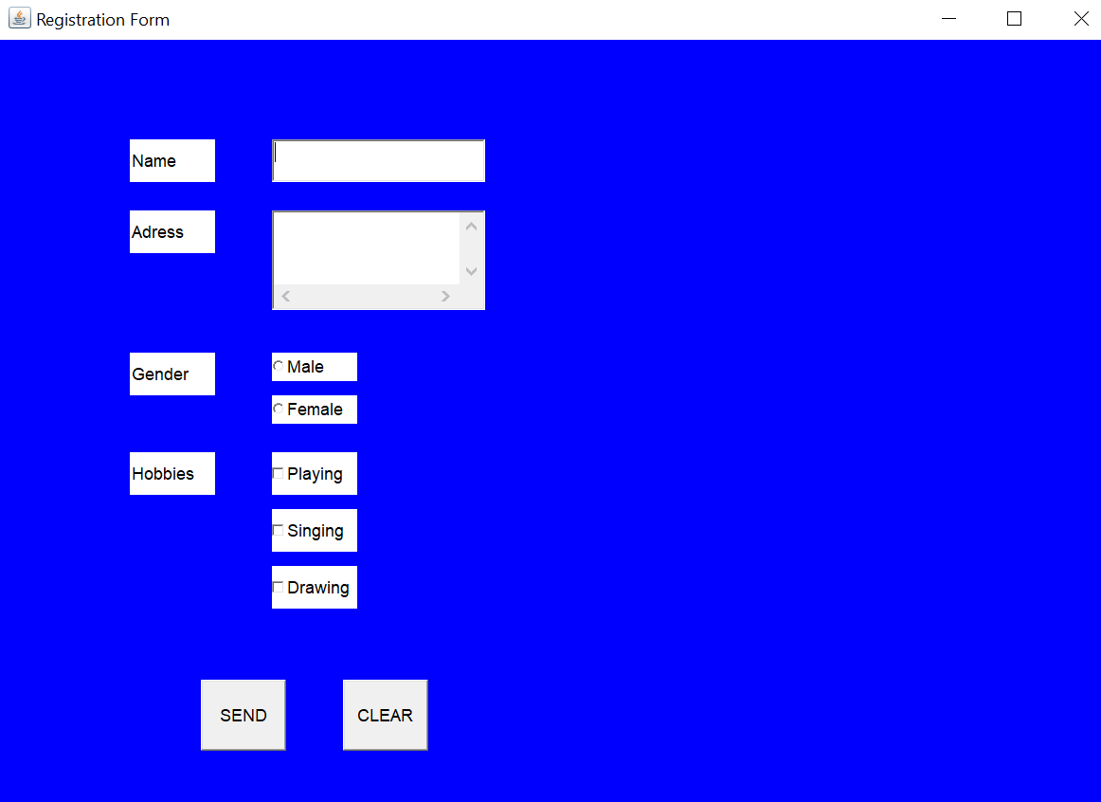

**Program :-**

import java.awt.*;

class Exp1_2 extends Frame{

Exp1_2() {

MenuBar m=new MenuBar();

Menu file=new Menu("File"); Menu edit=new Menu("Edit");

MenuItem new1=new MenuItem("New");MenuItem open=new MenuItem("Open");

MenuItem save=new MenuItem("Save");MenuItem file1=new MenuItem("File1");

MenuItem file2=new MenuItem("File2");file.add(new1);

file.add(open);file.add(save);edit.add(file1);edit.add(file2);

m.add(file);m.add(edit);setMenuBar(m);setVisible(true);

setSize(400,400);setLayout(new FlowLayout()); }

public static void main(String[] args) {

new Exp1_2(); }}

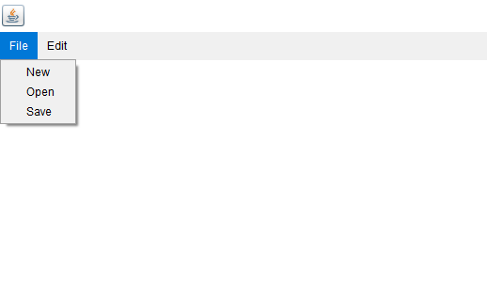

**Experiment No.:-2**

**Program :-**

import java.awt.*;

class Exp2_1 extends Frame{

Exp2_1() {

GridLayout g=new GridLayout(5,5,10,10);

Button b1=new Button("Button 1"); Button b2=new Button("Button 2");

Button b3=new Button("Button 3"); Button b4=new Button("Button 4");

Button b5=new Button("Button 5"); Button b6=new Button("Button 6");

Button b7=new Button("Button 7"); Button b8=new Button("Button 8");

Button b9=new Button("Button 9"); Button b10=new Button("Button 10");

Button b11=new Button("Button 11"); Button b12=new Button("Button 12");

Button b13=new Button("Button 13"); Button b14=new Button("Button 14");

Button b15=new Button("Button 15"); Button b16=new Button("Button 16");

Button b17=new Button("Button 17"); Button b18=new Button("Button 18");

Button b19=new Button("Button 19"); Button b20=new Button("Button 20");

Button b21=new Button("Button 21"); Button b22=new Button("Button 22");

Button b23=new Button("Button 23"); Button b24=new Button("Button 24");

Button b25=new Button("Button 25"); add(b1); add(b2); add(b3);

add(b4); add(b5); add(b6); add(b7); add(b8); add(b9);

add(b10); add(b11); add(b12); add(b13); add(b14); add(b15);

add(b16); add(b17); add(b18); add(b19); add(b20); add(b21);

add(b22); add(b23); add(b24); add(b25);

setLayout(g);setVisible(true);setSize(400,400);

setDefaultCloseOperation(EXIT_ON_CLOSE);

}

public static void main(String[] args) {

new Exp2_1();

}

}

**Output :-**

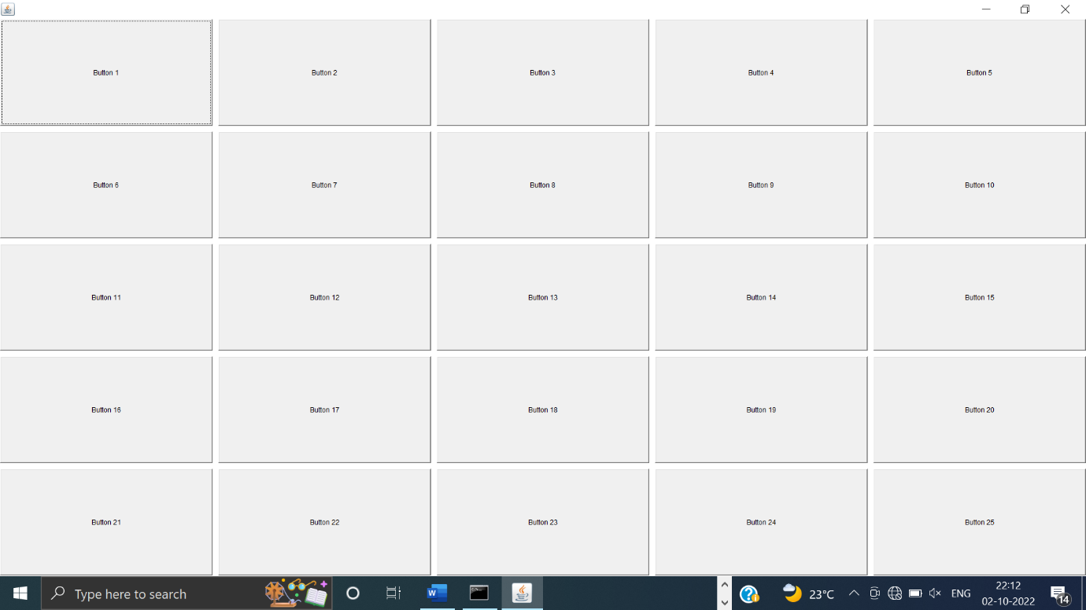

**Program :-**

import java.awt.*;

class Exp2_2 extends Frame{

Exp2_2() {

BorderLayoutbg=new BorderLayout(20,20);

Button north=new Button("North"); Button south=new Button("South");

Button east=new Button("East"); Button west=new Button("West");

Button center=new Button("Center"); add(north,bg.NORTH);

add(south,bg.SOUTH); add(east,bg.EAST); add(west,bg.WEST);

add(center,bg.CENTER);setSize(400,400);setVisible(true);

}

public static void main(String[] args){

new Exp2_2();

}

}

**Output :-**

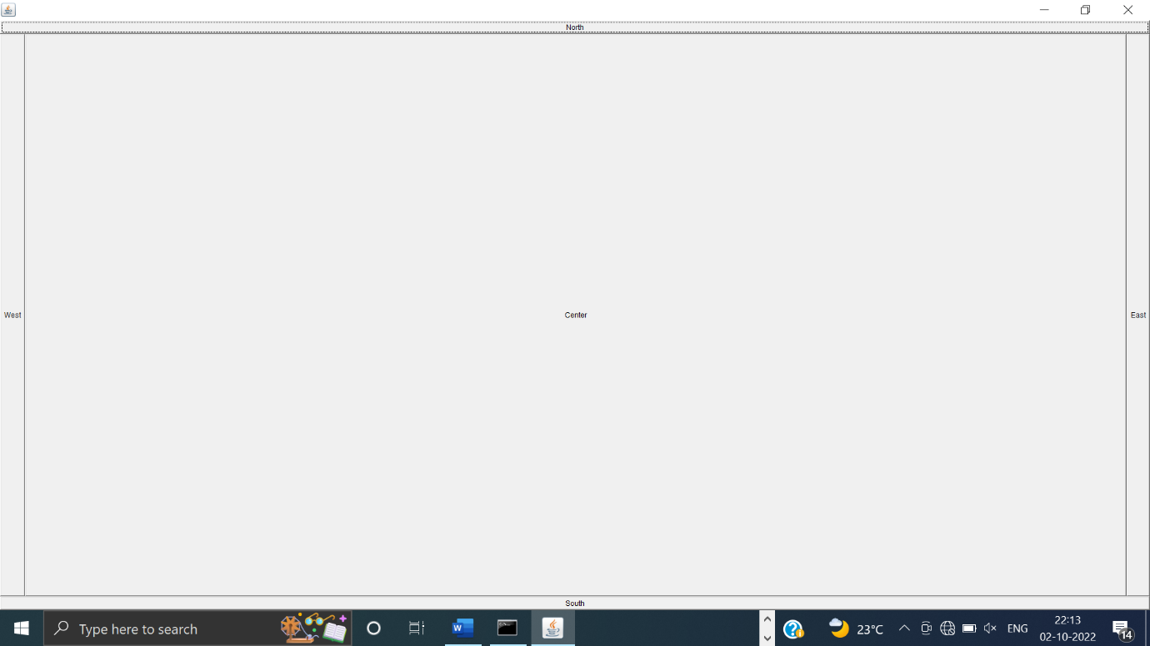

**Program :-**

import java.awt.*;

class Exp2_3 extends Frame{

Exp2_3() {

GridLayout g=new GridLayout(2,2);

Button b1=new Button("Button 1"); Button b2=new Button("Button 2");

Button b3=new Button("Button 3"); Button b4=new Button("Button 4");

add(b1); add(b2); add(b3) add(b4);

setLayout(g);setSize(400,400);setVisible(true);

}

public static void main(String[] args) {

new Exp2_3();

}

}

**Output :-**

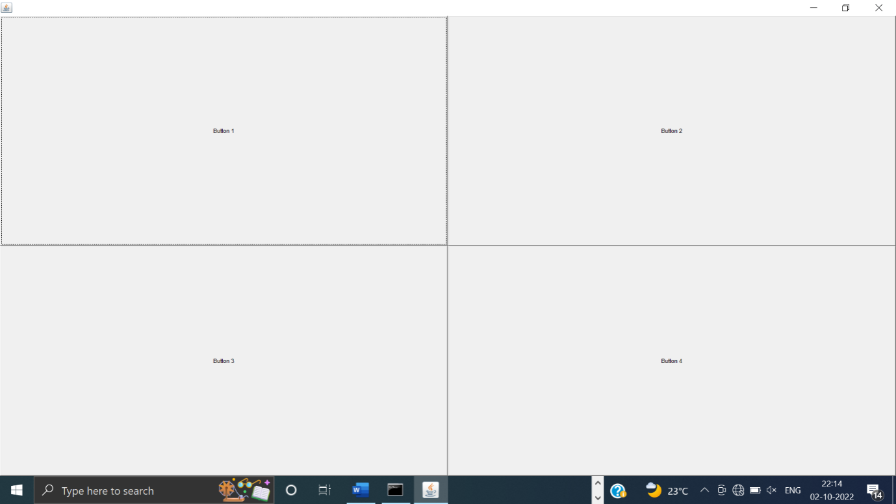

**Experiment No.:-3**

import javax.swing.*;

import java.applet.*;

import java.awt.*;

public class Exp31 extends JFrame{

Exp31() {

Container c=getContentPane();

c.setLayout(null);

JLabel l=new JLabel("Select state");

JComboBox j=new JComboBox();

j.addItem("Maharastra");j.addItem("Karanataka");j.addItem("Gujarat");

j.addItem("Keral");j.addItem("Madhyapradesh");j.addItem("Uttarpradesh");

j.addItem("Panjab");c.add(l);c.add(j);l.setBounds(40,50,100,20);

j.setBounds(40,75,100,60);

}

public static void main(String[] args){

Exp31 jc=new Exp31();

jc.setTitle("SITCOE");jc.setVisible(true);jc.setLayout(null);jc.setSize(600,600);

jc.setDefaultCloseOperation(JFrame.EXIT_ON_CLOSE);

}}

**Output :-**

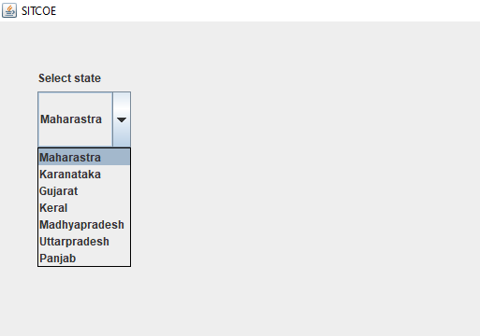

**Program :**

import java.awt.*;

import javax.swing.tree.*;

import javax.swing.*;

public class Exp3_2 extends JFrame{

Exp3_2() {

JFrame f=new JFrame("INDIA");

DefaultMutableTreeNodeindia=new DefaultMutableTreeNode("India");

DefaultMutableTreeNodemaharastra=new DefaultMutableTreeNode("Maharastra");

DefaultMutableTreeNodegujarat=new DefaultMutableTreeNode("Gujrath");

DefaultMutableTreeNodemumbai=new DefaultMutableTreeNode("Mumbai");

DefaultMutableTreeNodepune=new DefaultMutableTreeNode("Pune");

DefaultMutableTreeNodenashik=new DefaultMutableTreeNode("Nashik");

DefaultMutableTreeNodenagpur=new DefaultMutableTreeNode("Nagpur");

maharastra.add(mumbai);

maharastra.add(pune);

maharastra.add(nashik);

maharastra.add(nagpur);

india.add(maharastra);

india.add(gujarat);

JTree t=new JTree(india);

f.add(t);

f.setVisible(true);

f.setSize(800,800);

}

public static void main(String[] args)

{

new Exp3_2();

}

}

**Output :-**

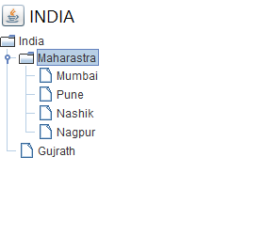

**Program :-**

import javax.swing.*;

class Exp3_3 extends JFrame{

Exp3_3() {

JFrame f=new JFrame();

String data[][]={ {"101","Amit","5000"}, {"102","Jay","10000"}, {"103","Sachin","15000"} };

String label[]={"ID","Name","Salary"};

JTable t=new JTable(data,label);

f.add(t);f.add(new JScrollPane(t));f.setSize(800,800);

f.setVisible(true);f.setLayout(null);

}

public static void main(String[] args) {

new Exp3_3();

}

}

**Output :-**

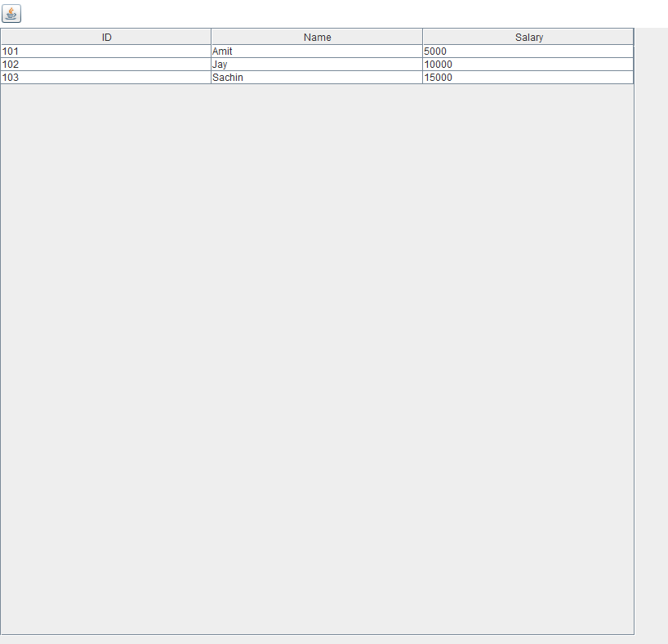

**Experiment No.:- 4**

**Output :-**

import java.awt.*;

import java.awt.event.*;

class Exp4_1 extends Frame implements KeyListener{

TextFieldt;Label l;

Exp4_1() {

t=new TextField(); l=new Label();

t.setBounds(50,50,100,30);l.setBounds(50,100,100,30);

t.addKeyListener(this); add(l); add(t);

setSize(800,800);setVisible(true);setLayout(null);

}

public void keyPressed(KeyEvent e){

l.setText("Key is Pressed");}

public void keyReleased(KeyEvent e){

l.setText("Key is Releassed");}

public void keyTyped(KeyEvent e){

l.setText("Key is Typed");}

public static void main(String[] args){

new Exp4_1();

}}

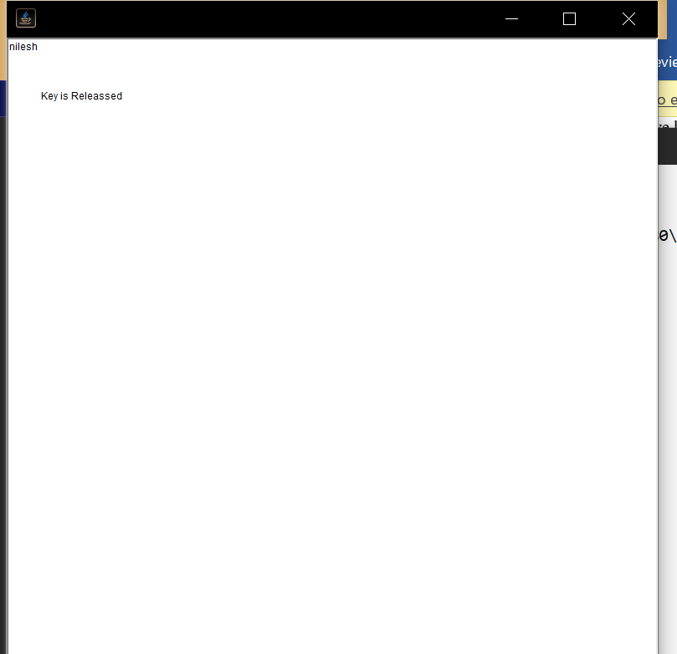

**Program :**

import java.applet.*;

import java.awt.*;

import java.awt.event.*;

//<applet code="Exp42" width=800 height=800></applet>

public class Exp42 extends Applet implements MouseListener {

Colorcolor = Color.green;

public void init(){

addMouseListener(this);

}

public void paint(Graphics g){

setBackground(color);

}

public void mouseClicked(MouseEvent e){

this.color = color.red;this.repaint();

}

public void mouseEntered(MouseEvent e) {}

public void mouseExited(MouseEvent e) {}

public void mousePressed(MouseEvent e) {}

public void mouseReleased(MouseEvent e) {}

}

**Output :-**

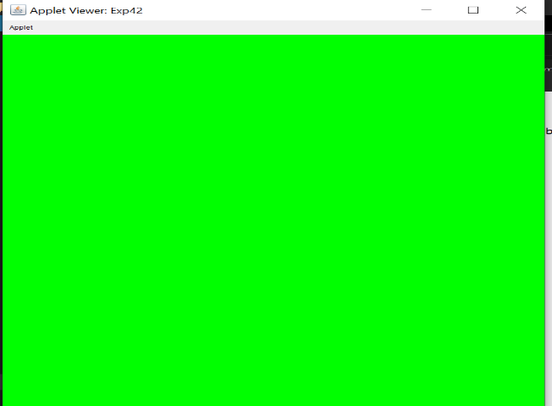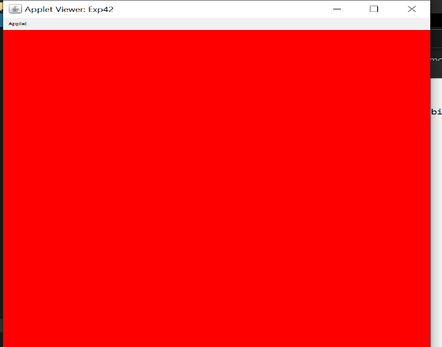

**Experiment No.:- 5**

**Program :-**

import java.awt.event.*;

import java.awt.*;

class Exp5_1 extends WindowAdapter{

Frame f;

Exp5_1() {

f=new Frame();f.addWindowListener(this);

f.setSize(800,800);f.setVisible(true);f.setLayout(null);

}

public void windowOpened(WindowEvent e) {

System.out.println("Window is open");

}

public static void main(String[] args){

new Exp5_1();

}

}

**Output :-**

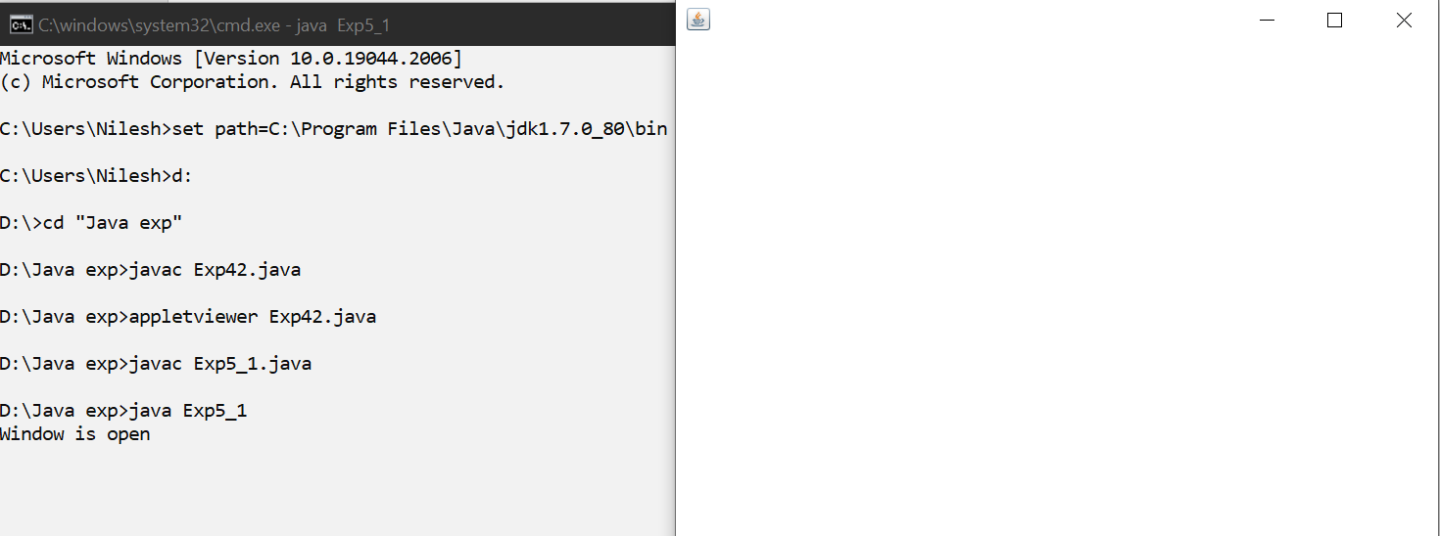

**Program :**

import java.awt.event.*;

import java.awt.*;

import java.awt.Graphics.*;

class Exp5_2 extends MouseMotionAdapter{

Frame f; Label l;

Exp5_2() {

f=new Frame(); l=new Label();

f.add(l);l.setBounds(50,50,80,30);

f.addMouseMotionListener(this);

f.setSize(800,800);f.setVisible(true);f.setLayout(null);

}

public void mouseDragged(MouseEvent e) {

l.setText("Mouse is Dragged");

}

public static void main(String[] args){

new Exp5_2();

}}

**Output :-**

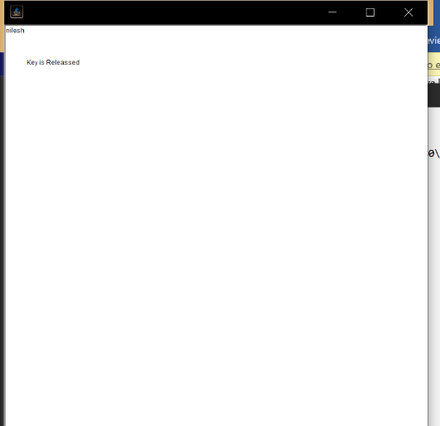

**Program :-**

import javax.swing.*;

class Exp5_3{

public static void main(String[] args) {

JFrame f=new JFrame("Password Field Example");

JPasswordField value = new JPasswordField();

value.setEchoChar('#');

JLabel l2=new JLabel("Email ID :");

l2.setBounds(20,100,120,30);

f.add(l2);

JTextField jf=new JTextField();

jf.setBounds(100,100,100,30);

f.add(jf);

JLabel l1=new JLabel("Password :");

l1.setBounds(20,180, 120,30);

value.setBounds(100,180,100,30);

f.add(value);

f.add(l1);

f.setSize(800,800);

f.setLayout(null);

f.setVisible(true);

}

}

**Output :-**

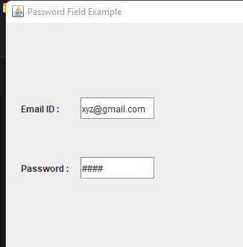

**Experiment no 6**

**1)Develop a program using InetAddress class to retrive IP address of computer when hostname is entered by user.**

import java.io.*;

import java.net.*;

public class InetDemo{

public static void main(String[] args){

try{

InetAddress ip=InetAddress.getByName("www.facebook.com");

System.out.println("Host Name: "+ip.getHostName());

System.out.println("IP Address: "+ip.getHostAddress());

}catch(Exception e){System.out.println(e);}

}

}

OUTPUT

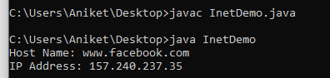

**2)Write a program using URL class to retieve the host, protocol, port and file of URL https://sitcoe.ac.in/**

import java.net.*;

public class URLDemo{

public static void main(String[] args){

try{

URL url=new URL("https://sitcoe.ac.in/SITCOE");

System.out.println("Protocol: "+url.getProtocol());

System.out.println("Host Name: "+url.getHost());

System.out.println("Port Number: "+url.getPort());

System.out.println("File Name: "+url.getFile());

}catch(Exception e){System.out.println(e);}

}

}

OUTPUT

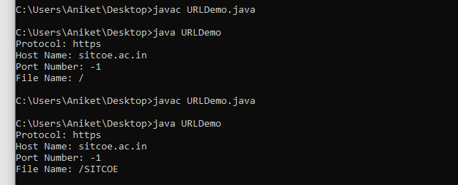

Experiment no 7

**Write a program using socket and ServerSocket to create chat application.**

**Server side**

import java.io.*;

import java.net.*;

public class MyServer {

public static void main(String[] args){

try{

ServerSocket ss=new ServerSocket(6666);

Socket s=ss.accept();//establishes connection

DataInputStream dis=new DataInputStream(s.getInputStream());

String str=(String)dis.readUTF();

System.out.println("message= "+str);

ss.close();

}catch(Exception e){System.out.println(e);}

}

}

**Client side**

import java.io.*;

import java.net.*;

public class MyClient {

public static void main(String[] args) {

try{

Socket s=new Socket("localhost",6666);

DataOutputStream dout=new DataOutputStream(s.getOutputStream());

dout.writeUTF("Hello Server");

dout.flush();

dout.close();

s.close();

}catch(Exception e){System.out.println(e);}

}

}

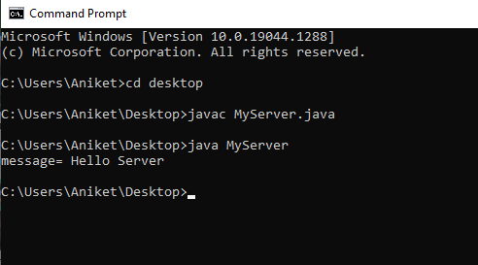

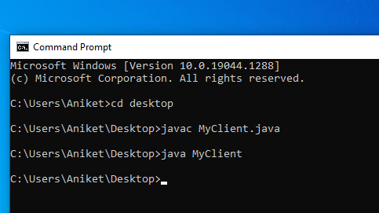

**2)Write a program using DatagramPacket and DatagramSocket to create chat application.**

**SENDER**

import java.net.*;

public class DSender{

public static void main(String[] args) throws Exception {

DatagramSocket ds = new DatagramSocket();

String str = "Welcome java";

InetAddress ip = InetAddress.getByName("127.0.0.1");

DatagramPacket dp = new DatagramPacket(str.getBytes(), str.length(), ip, 3000);

ds.send(dp);

ds.close();

}

}

**RECEIVER**

import java.net.*;

public class DReceiver{

public static void main(String[] args) throws Exception {

DatagramSocket ds = new DatagramSocket(3000);

byte[] buf = new byte[1024];

DatagramPacket dp = new DatagramPacket(buf, 1024);

ds.receive(dp);

String str = new String(dp.getData(), 0, dp.getLength());

System.out.println(str);

ds.close();

}

}

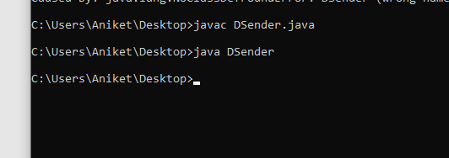

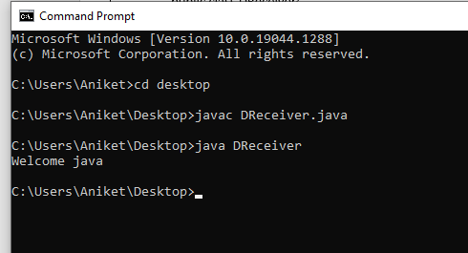

**Experiment no 8**

Q1.

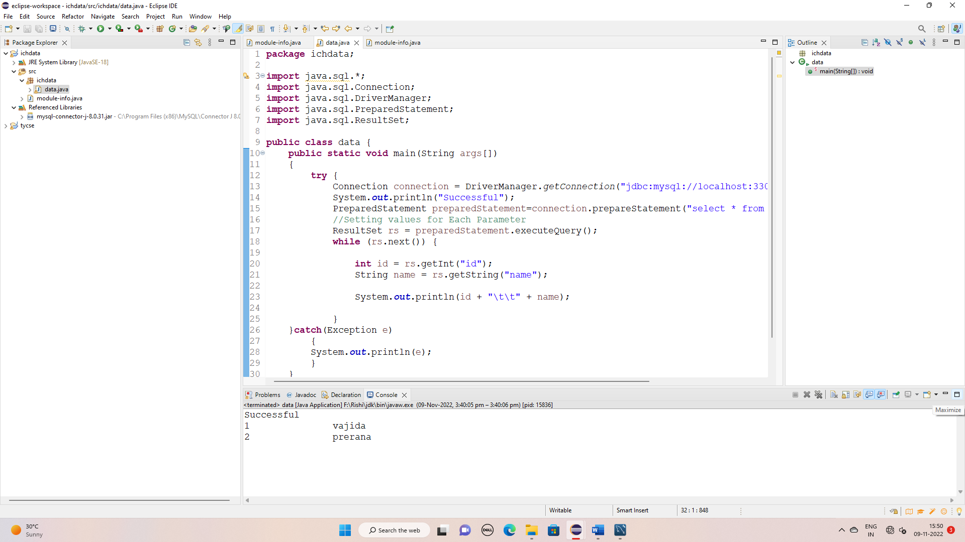

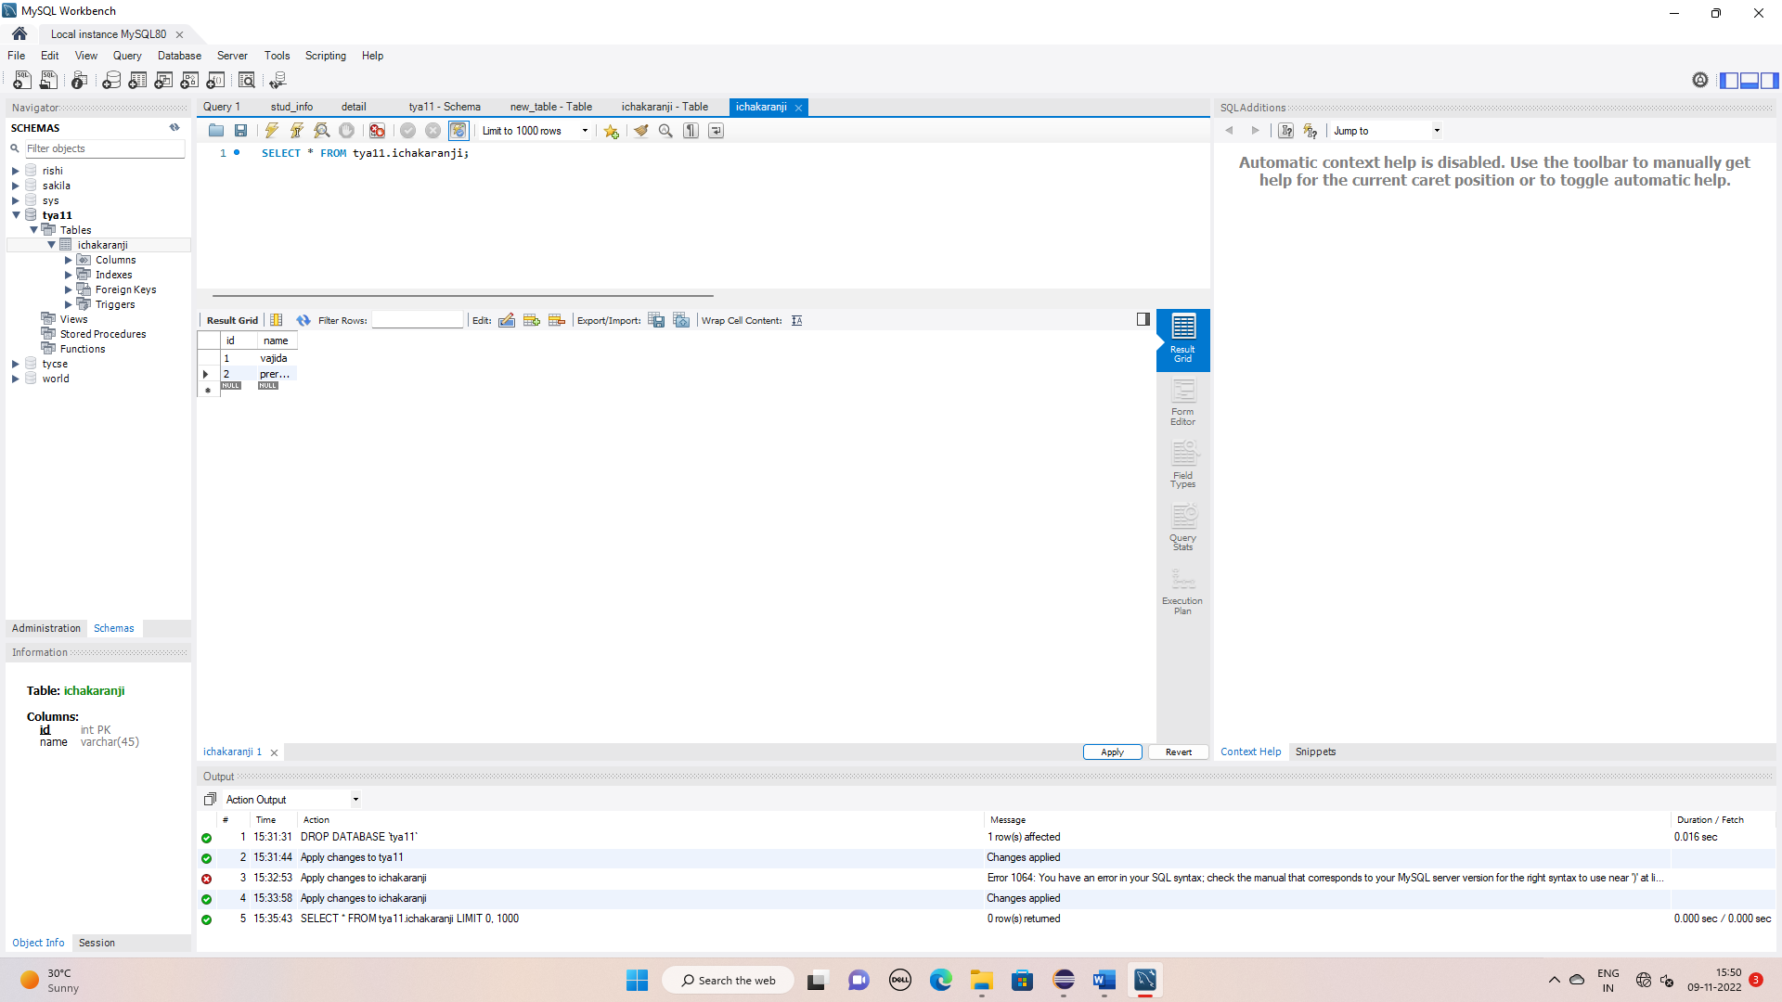

Q2.

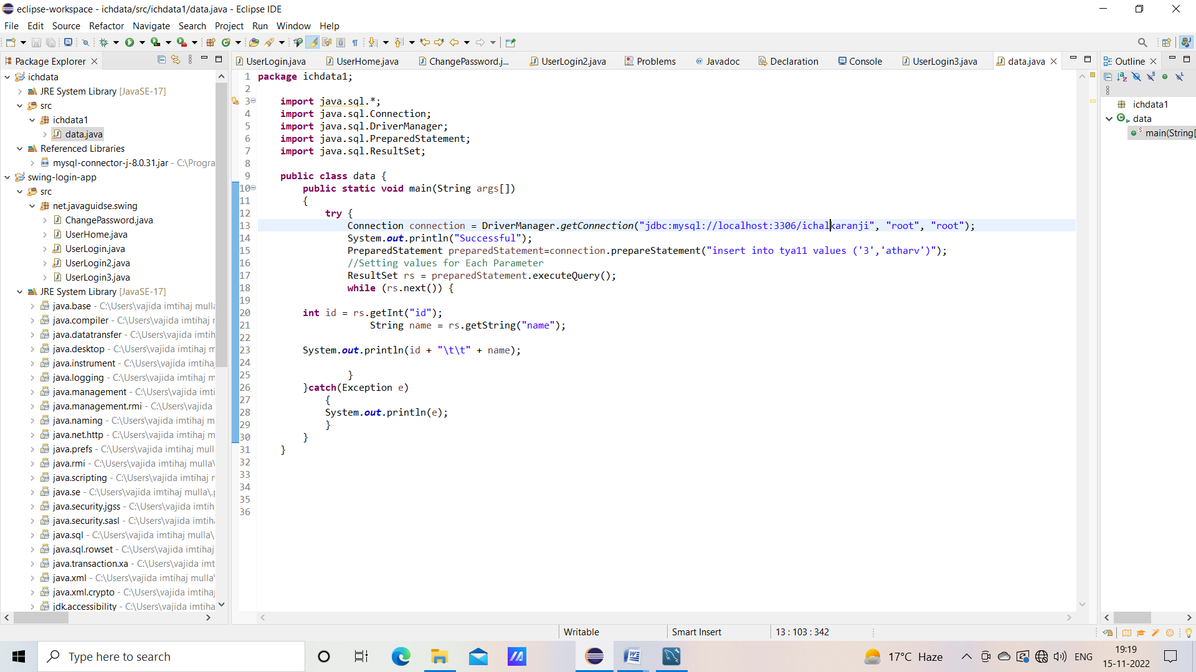

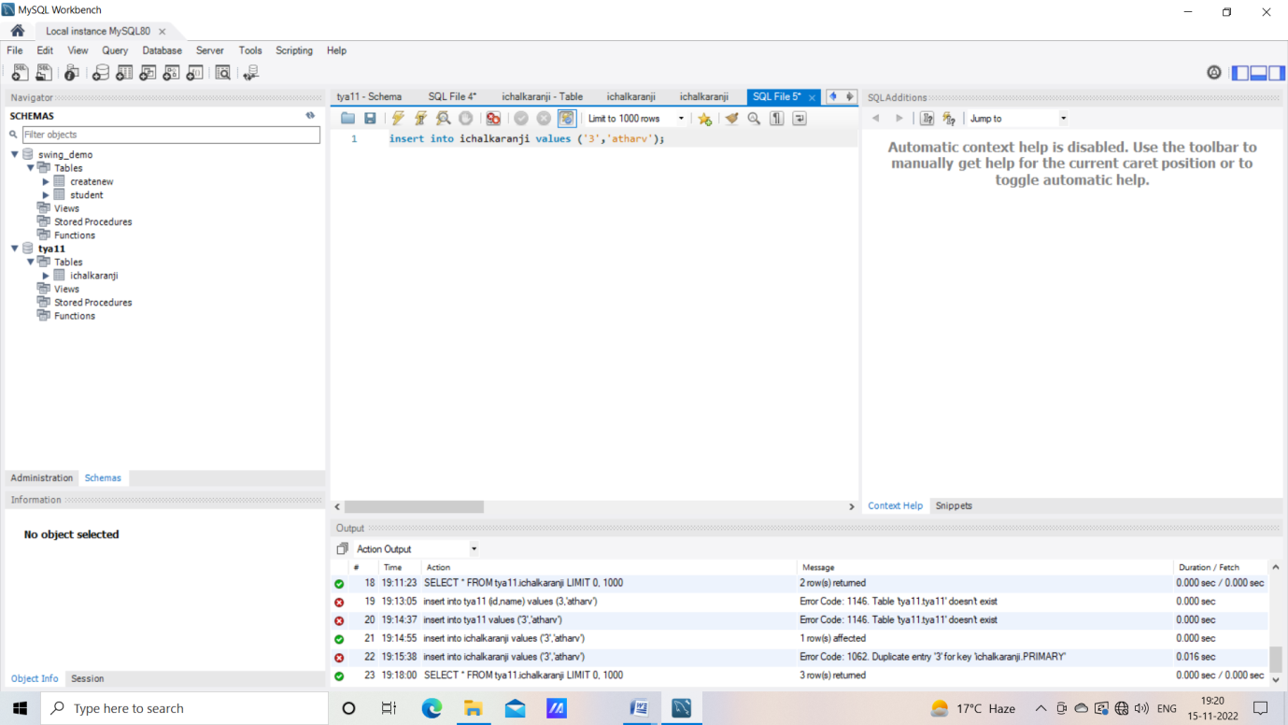

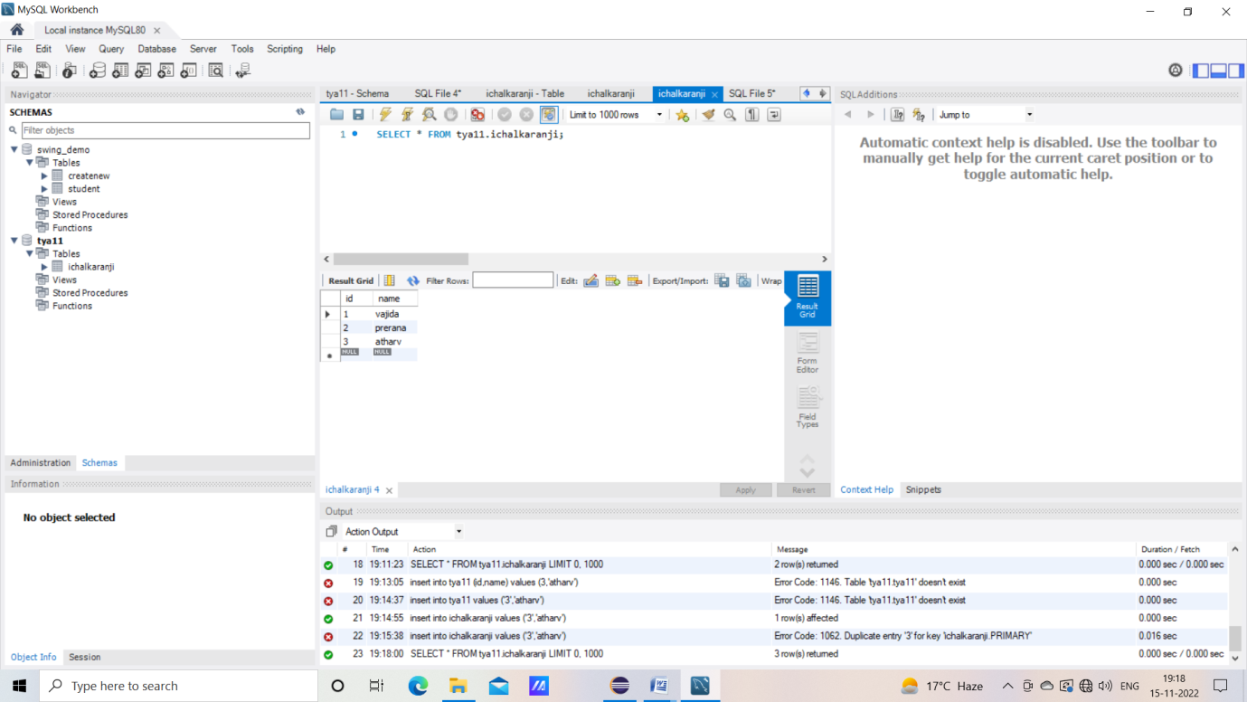

**Exp. 09 :**

1.

import java.io.*;

import javax.servlet.*;

import javax.servlet.http.*;

public class display extends HttpServlet

{

public void doPost(HttpServletRequest req,HttpServletResponse res)

throws ServletException,IOException

{

//String lang=req.getParameter("Language");

res.setContentType("text/html");

PrintWriter pw=res.getWriter();

java.util.Date date = new java.util.Date();

pw.println("<h2>"+"Current Date & Time: " +date.toString()+"</h2>");

pw.close();

}

}

Output :

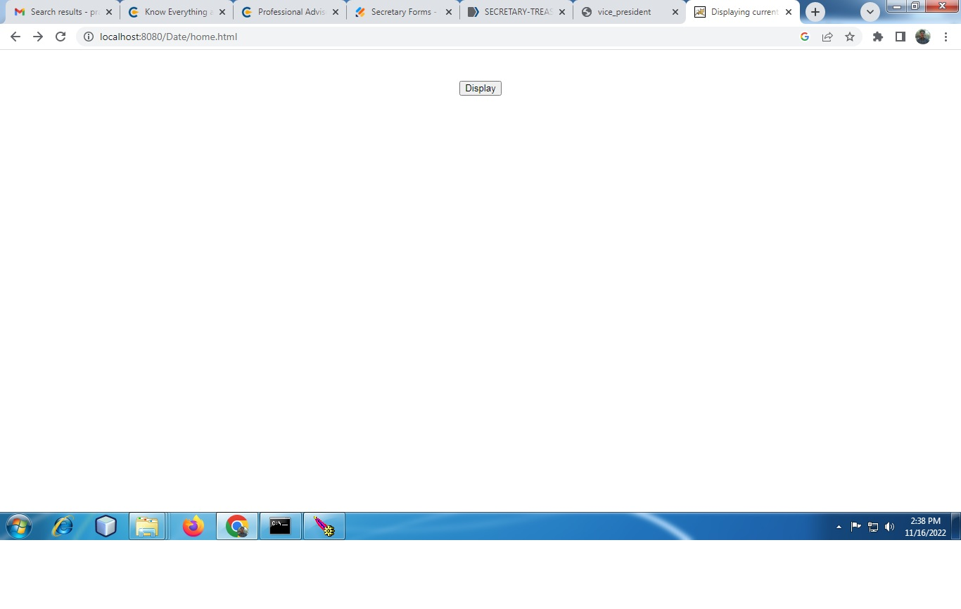

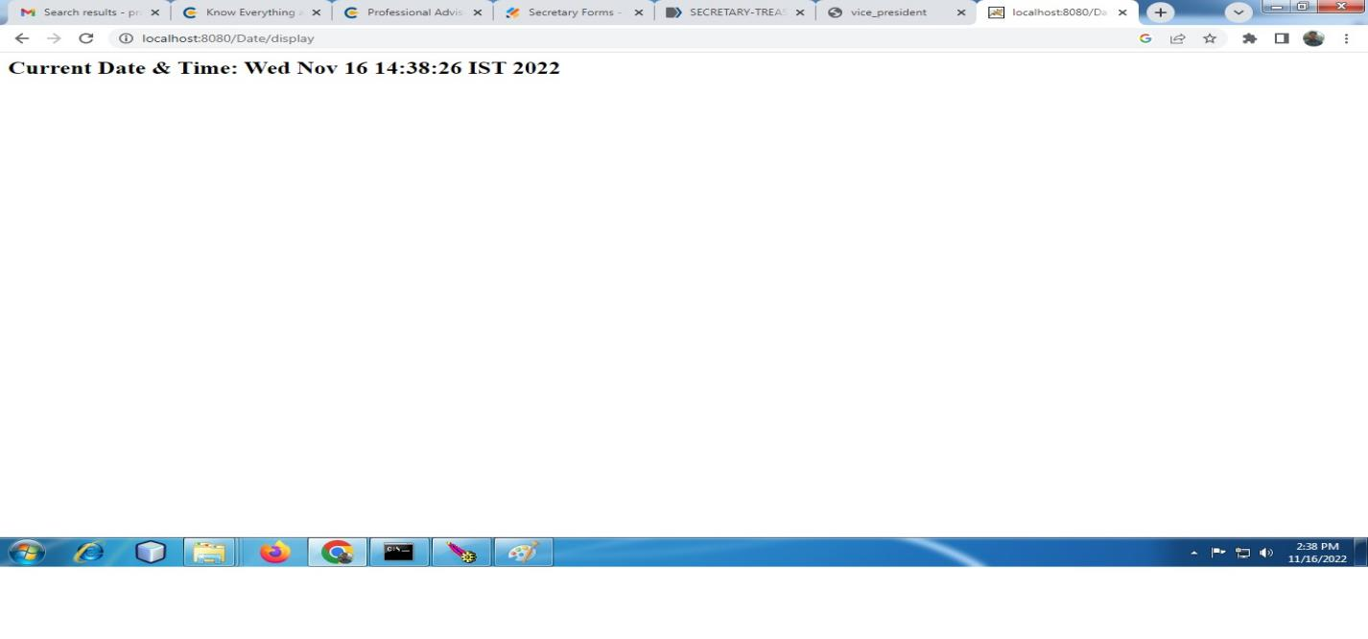

2.

import java.io.*;

import javax.servlet.*;

import javax.servlet.http.*;

public class addition extends HttpServlet

{

public void doPost(HttpServletRequest req,HttpServletResponse res)

throws ServletException,IOException

{

//String lang=req.getParameter("Language");

res.setContentType("text/html");

PrintWriter pw=res.getWriter();

//get request parameters for userID and password

int a=Integer.parseInt(req.getParameter("Number1"));

int b=Integer.parseInt(req.getParameter("Number2"));

int c=a+b;

pw.println("<h4>The addition is:="+c+"</h4>");

pw.close();

}

}

Output :

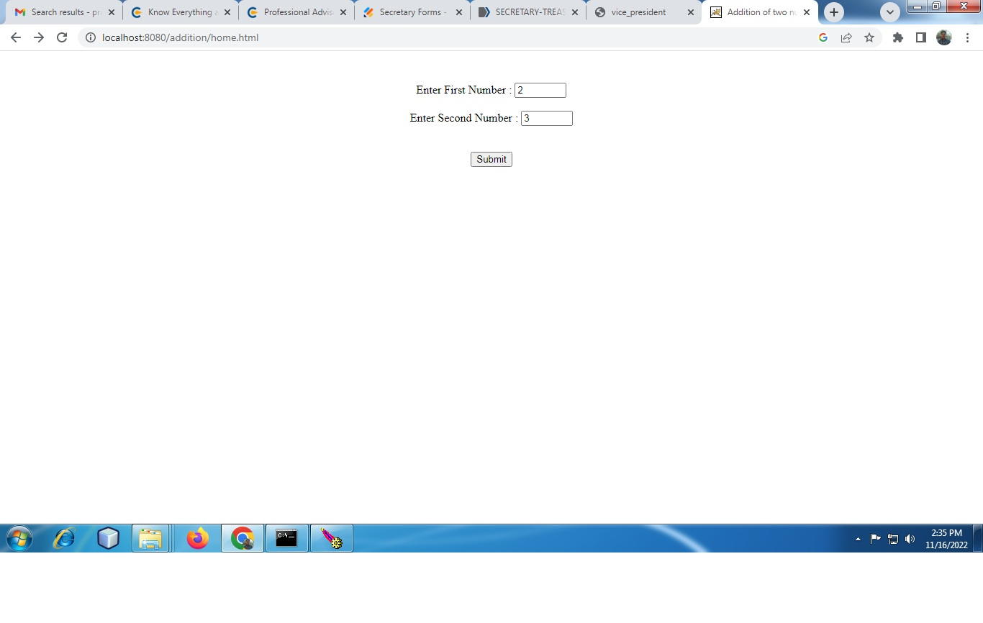

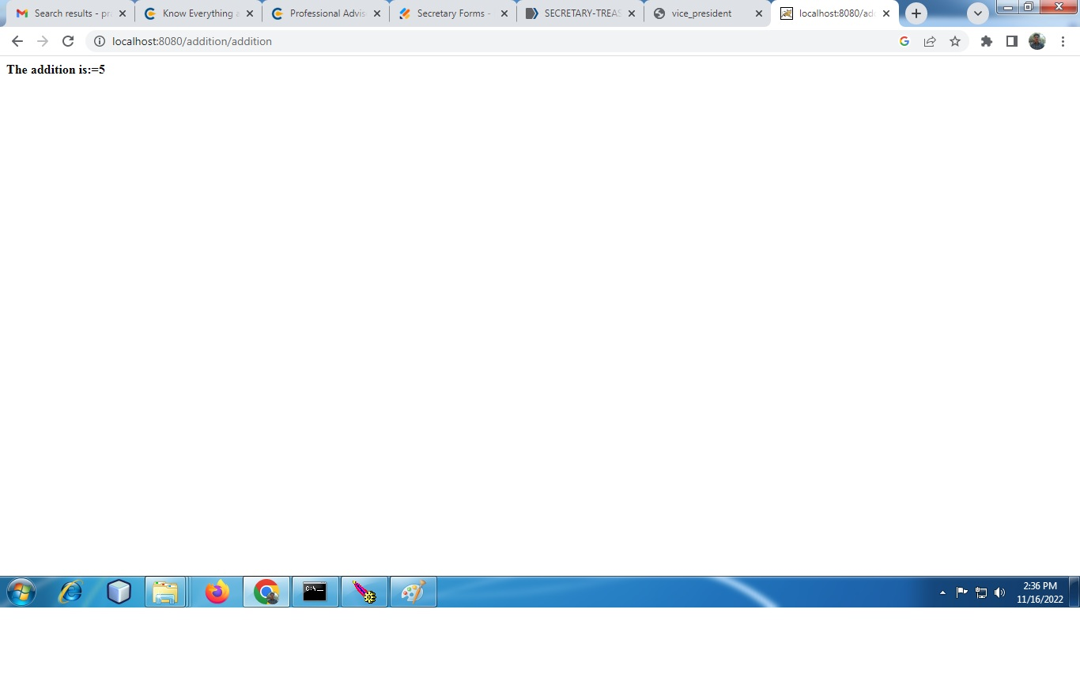

**Exp. 10 :**

**Q1**

import java.io.*;

import java.util.*;

import javax.servlet.*;

import javax.servlet.http.*;

public class session extends HttpServlet {

public void doGet(HttpServletRequest request, HttpServletResponse response)

throws IOException, ServletException

{

response.setContentType("text/html");

PrintWriter out = response.getWriter();

HttpSession session = request.getSession(true);

Date created = new Date(session.getCreationTime());

Date accessed = new Date(session.getLastAccessedTime());

out.println("Session Information");

out.println("ID ::" + session.getId());

out.println("Created:: " + created);

out.println("Last Accessed:: " + accessed);

}

}

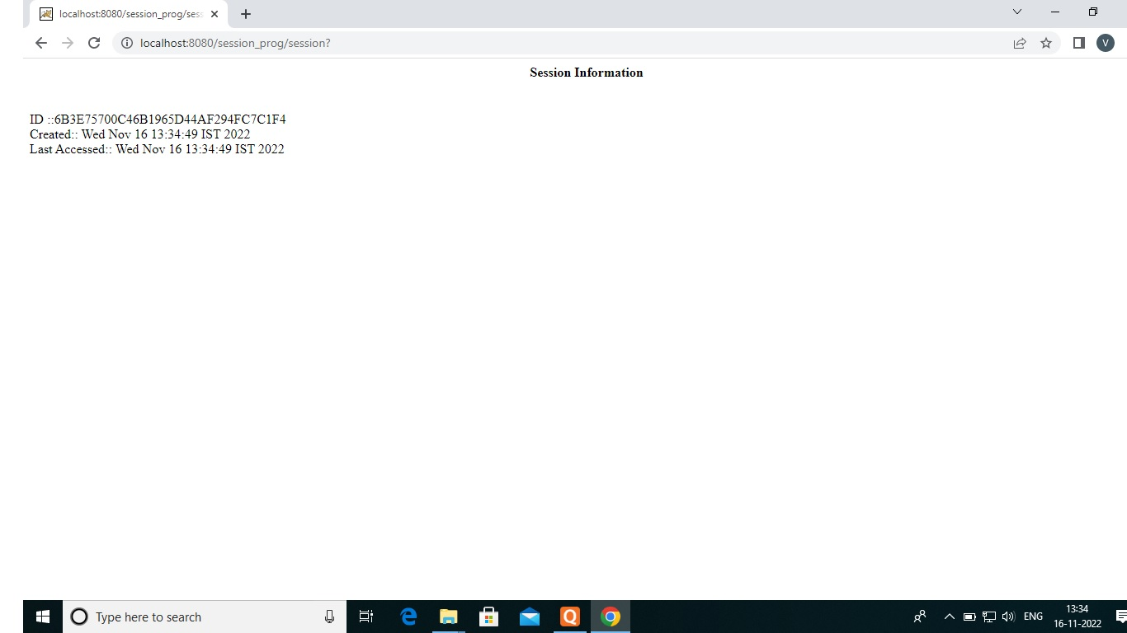

**Q2**

**//FirstSevlet**

import java.io.*;

import javax.servlet.*;

import javax.servlet.http.*;

public class FirstServlet extends HttpServlet {

public void doPost(HttpServletRequest request, HttpServletResponse response){

try{

response.setContentType("text/html");

PrintWriter out = response.getWriter();

String n=request.getParameter("userName");

out.print("Welcome "+n);

Cookie ck=new Cookie("uname",n);//creating cookie object

response.addCookie(ck);//adding cookie in the response

//creating submit button

out.print("<form action='servlet2' method='post'>");

out.print("<input type='submit' value='go'>");

out.print("</form>");

out.close();

}catch(Exception e){System.out.println(e);}

}

}

**//SecondServlet**

import java.io.*;

import javax.servlet.*;

import javax.servlet.http.*;

public class SecondServlet extends HttpServlet {

public void doPost(HttpServletRequest request, HttpServletResponse response){

try{

response.setContentType("text/html");

PrintWriter out = response.getWriter();

Cookie ck[]=request.getCookies();

out.print("Hello "+ck[0].getValue());

out.close();

}catch(Exception e){System.out.println(e);}

}

}

